As I start my second term as Coordinator for Region 6 it seems like yesterday that
I took over this position. The opportunity to do this service is a true gift, keeping
me on my OA journey as I look forward to our spring Assembly. We now provide
bi-lingual information to our French membership, and it has been a most
wonderful journey to ensure that the information going out to everyone is in both
English and French where possible. Service is what keeps OA alive and well and
we need all of you to help us to do the business of the Region. It is so important
to bring back all the information learned at Assembly to your Intergroup. This
helps your Intergroup members understand what Region 6 does and how
important it is to OA as a whole. Don’t forget to let your Intergroup know about
the fellows you meet and the fun you have as it isn’t all business, to encourage
them to consider doing service at the Region 6 level.

Fall 2023 Assembly Registration Information:
Representatives 33
Alternates 3
Guest 1
Board 6
Trustee 1
Parliamentarian 1
CMM 1
Total 46

Blue Dots (1st time assembly attendance) 4
Intergroups Represented at Assembly 22

Committee Assignments
Region 6 has 7 committees to do the work of the Region. When you complete your registration for the Assembly you are asked to choose 3 committees in order of preference. We try to take everyone’s first choice into consideration when the committees are assigned. It was wonderful to hold our committee meetings in person this past year, sharing ideas getting a greater understanding of the committee and how to work together. We are looking forward to all the ideas that come out of our spring assembly committees.

How We Keep You Up To Date
We use Constant Contact as our Email distribution service. If you have missed an email from Region 6, please go the Region 6 website click here to subscribe to our newsletter.
If you unsubscribed in error or would like to re-subscribe click here and click on Subscribe to Newsfeed button, input your email address, click on the Sign-Up button. If you have any questions do not hesitate to contact me at coordinator@oaregion6.org.
We do our very best not to over burden your mailboxes while keeping you up todate with Region activities and World Service notices.

UPDATES TO INTERGROUPS AND MEETINGS

Updating your Intergroup Information
To update your Intergroup information please go to the World Service (WSO)
website and click here to make all your updates. Once completed we ask you to
forward the information to coordinator@oaregion6.org . Region 6 needs the
following updates: address, contact information for chair and secretary, as well
changes to your website location i.e., URL.

Updating Local Meeting Information
World Service is asking that meeting updates be provided to keep their database up to date. Remember our primary purpose is to carry the message to the still suffering compulsive eater and when a potential new or returning OA member goes to the oa.org website looking for a meeting it is very important the meeting information is up to date. Thank you for your support and service.
Here are some links to assist you with managing this information:
• To Add, Edit or Cancel a Meeting with WSO: Visit oa.org/add-a-meeting, click on the appropriate tab and complete the form to update the information. To find your meeting number, go to oa.org/find-a-meeting and follow the prompts.
• Editing Intergroup Information with WSO: Click here to locate the change form to update the information. To find your IG number click here, complete the fields and make your selection.
Service Body Reports Comparison
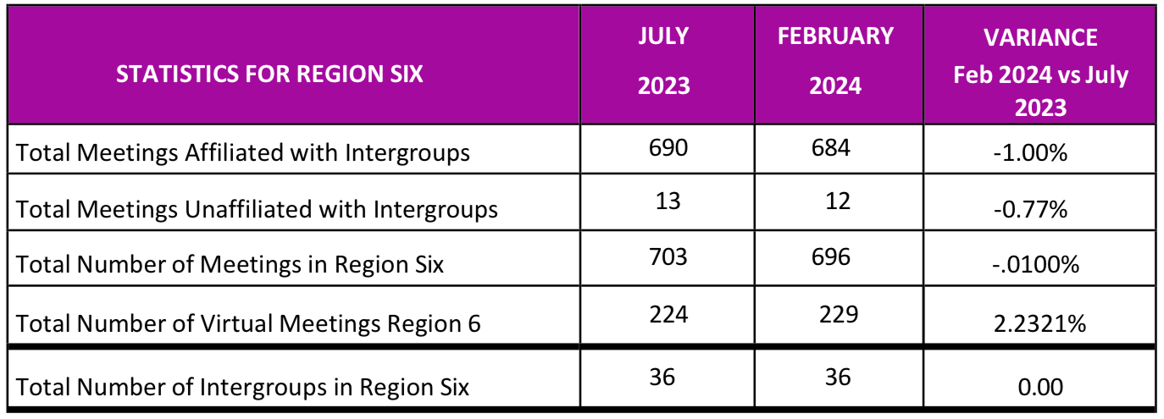
The chart above shows the shift over the past six months. Our meeting landscape is changing, as you can see there are a total of 229 Virtual meetings in Region 6 up 2.2321% from July 2023.
In July 2023, the meeting count was 703; now as of February 2024 the meeting count is 696; this represents a decrease of 1.00%. You can see Region 6 meeting numbers are being updated with World Service and we want to thank you and your membership for the work done. We are still asking all Intergroups and meetings to continue to update their status by closing meetings if they are no longer active and registering new meetings. This will enable the Region and WSO to get an accurate count of our meetings.
Please remember our primary purpose:
To carry the message to the still suffering compulsive eater. Thank you all for your service.
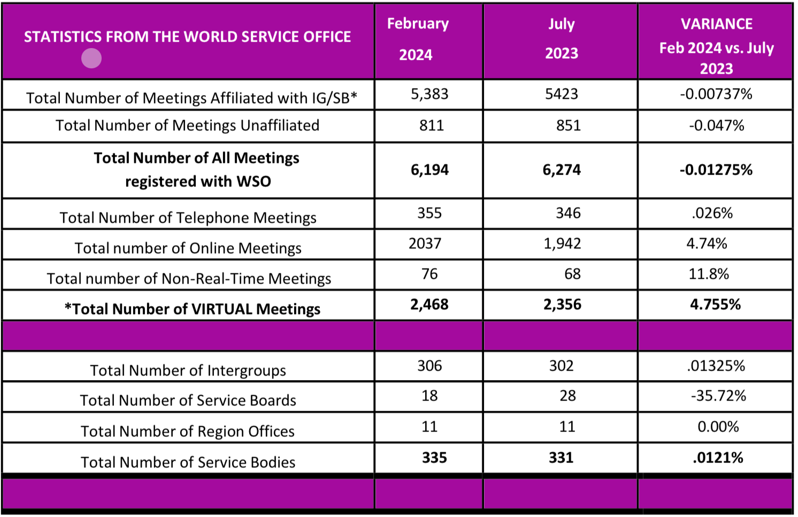
NOTE: Virtual Meetings are included in the Total Number of Meetings count

Above are statistics from the World Service Office as of February 2024 compared with July 2023.

