I have been serving in the Web and Pub chair since the Fall Assembly. I would have
gotten practically nowhere without the support of my predecessor, Chuck F., and we should all thank him!

Home page
In the run up to the Spring Assembly, we changed one of the three rotating windows at the top to focus on registration and access to documents. We put that window first, so that visitors to the site would see that first.
We repurposed space below left of the carousel to show our blog’s most recent headlines. It previously was addressed to newcomers, as was the space immediately to its right.
We’ve made quite a few changes to the main menu. The main headings now are:
* About: Links to about OA, bylaws, our newcomers’ information, IGs in R6, and contact info.
* Committees: Each committee now has a link here, both for explanations of purpose and to track what each committee is doing.
* Contribute: Unchanged.
* Events: Links for the Intergroup Forum, Convention, Assembly, and our full calendar.
* Infos en Francais: We’re adding content in French continually, most recently a page for the Spring Assembly.
* News: The main feature now is our revived blog.
* Resources: Bylaws link, downloadable documents, scholarships docs, a call for service, recovery recordings, a best-internet-practices link, including Zoom safety and anonymity.

Blog
About 10 posts in the past 6 months, with a plan to add 25-30 posts per year. All Will appear in the main blog roll, but subsets by subject matter will also appear elsewhere on our site — so, for example, posts about the monthly forum will also appear on the forum page.
* All committee reports from each assembly will now be blog posts, instead of being transmitted solely on paper and shared only with those at Assembly. Over time, these will accrue as a record of what each committee is doing.
* Each board member will write at least two blog posts a year, to keep members informed on their work.
* Each email we send out with Region business will also become a blog post, so that those who miss the email will still have a chance to see the information.
* Selected news sent out by the World Service Office will also be included.
A benefit is that by having frequent additions to our site, oaregion6.org, will
appear higher in organic-search results. Google values sites with dynamic content.

Calendar
We completed a transition to a calendar by teamup. We’d already been using it to allow anyone to post 12 Step-related events (with a vetting process after posting), but we were using a separate calendar for other purposes. Sub calendars that anyone can use list retreats and workshops. Password-protected calendars include Assembly, Convention, R6 deadlines, board calendar, and our intergroup forum.
This app allows us to publish our sub calendars elsewhere, so that Assembly dates can also be posted on the Assembly page, etc.
We must post all the Regions’ important events, for transparency and clarity. But every time an IG posts an event, it makes the calendar a more valuable resource.
Please ask your intergroup to a) post its events there, and b) spread the word to members that it’s a good place to look for recovery-related events.
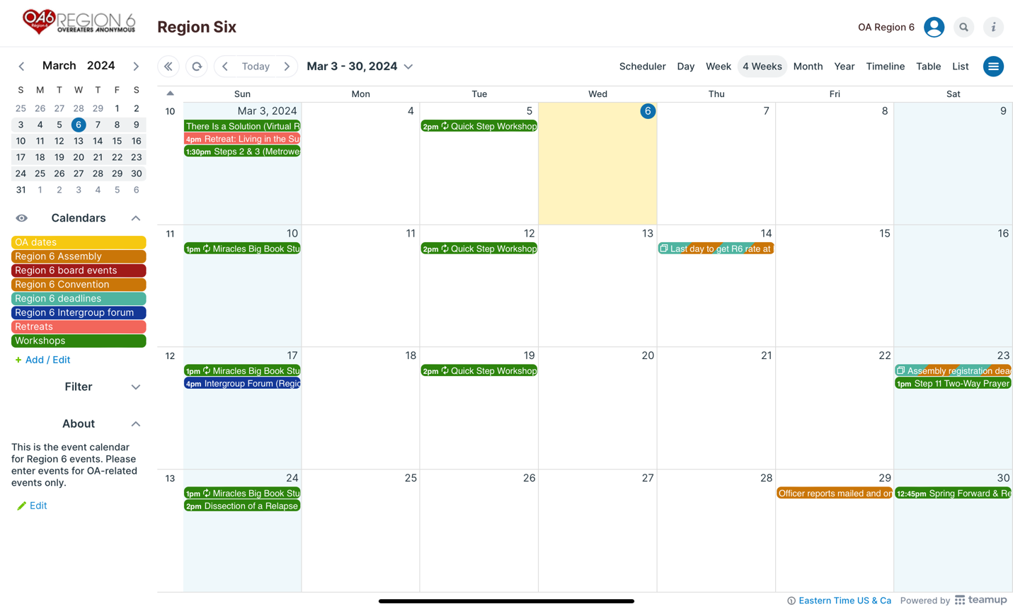
Recovery recordings
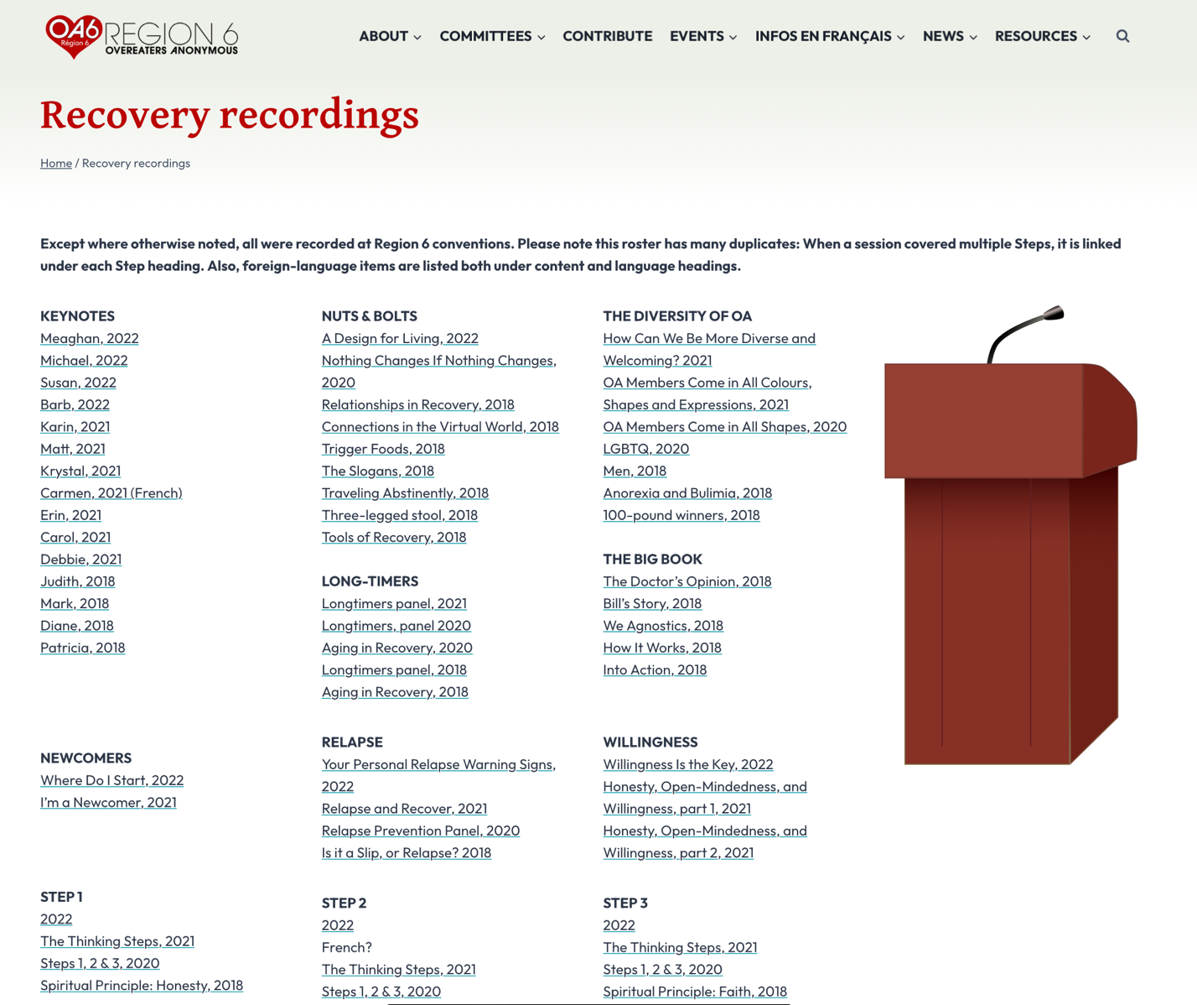
We have uploaded recordings from our conventions in 2018, 2020, 2021, and 2022. We will post our 2023 recordings soon and continue posting them in the future. They are hosted on a platform that provides stats that identify the most-downloaded recordings. We recently added a recovery recordings page to the site, which organizes them by topic, as well as by year.

